***Results***

1. **Model Training and Loading the model**

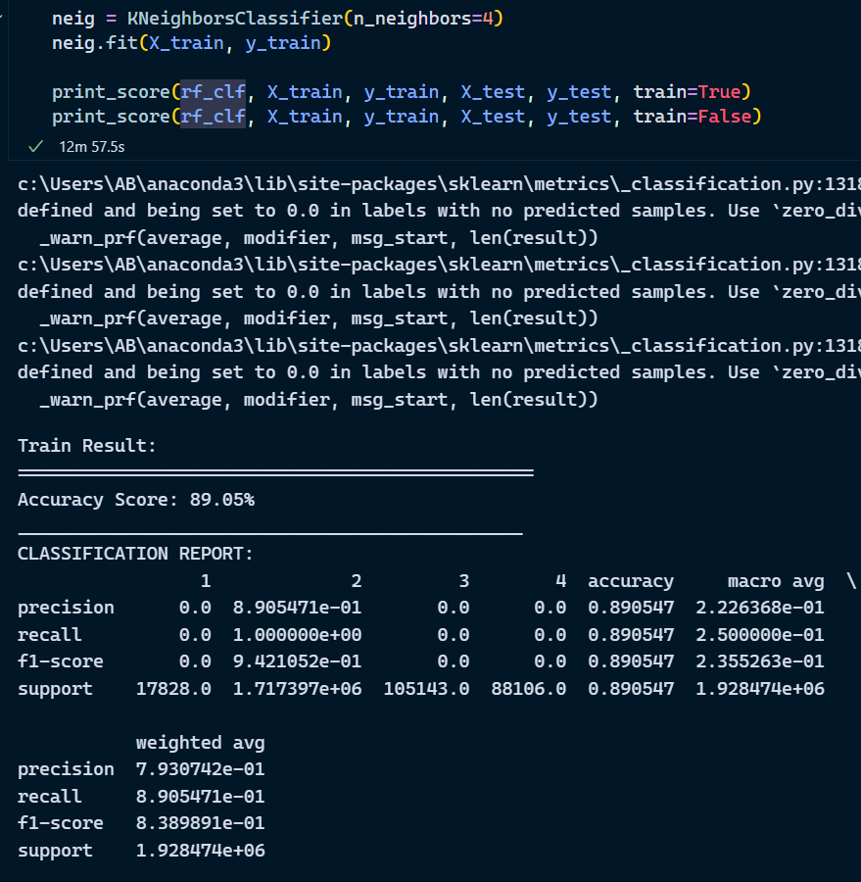

1. ***Sequential Feature Selector***

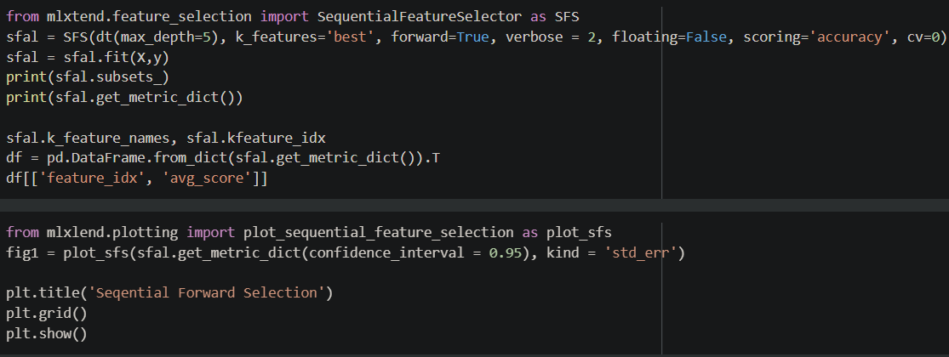

***Exploratory Data Analysis***

1. ***Missing values heatmap***

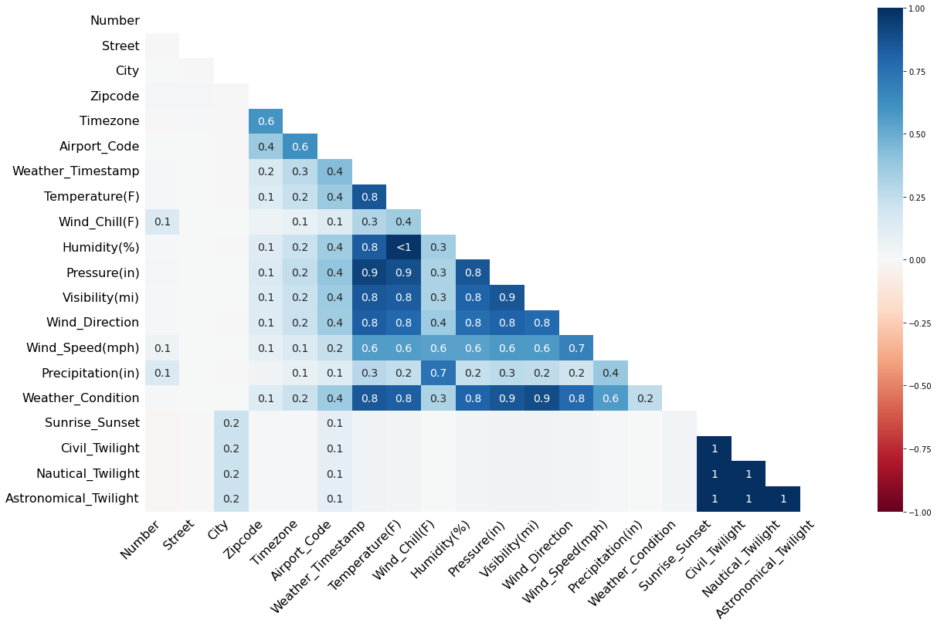

1. ***Coordinate clusters***

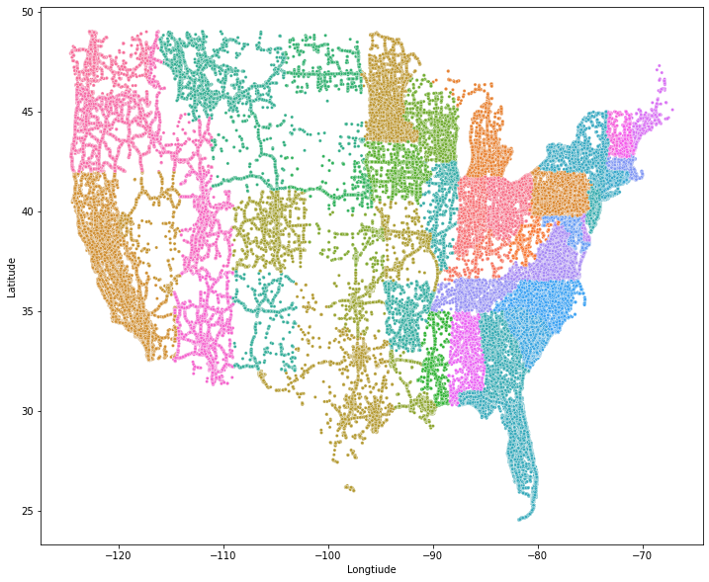

1. ***Heatmap of accidents***

